Keras nn

# --- Keras Sequential NN ---
def create_keras_model():
model = keras.Sequential([
keras.layers.Input(shape=(2,)),
keras.layers.Dense(128, activation='relu'),
keras.layers.Dense(128, activation='relu'),
keras.layers.Dense(1, activation='sigmoid')
])
model.compile(optimizer='adam', loss='binary_crossentropy', metrics=['accuracy'])
return model

# --- Manual Keras NN wrapper ---
class KerasNNWrapper:
def __init__(self):
self.scaler = StandardScaler()
self.model = None

def fit(self, X, y):
X_scaled = self.scaler.fit_transform(X)
self.model = keras.Sequential([
keras.layers.Input(shape=(2,)),
keras.layers.Dense(128, activation='relu'),
keras.layers.Dropout(0.2),
keras.layers.Dense(128, activation='relu'),
keras.layers.Dense(1, activation='sigmoid')
])
self.model.compile(optimizer='adam', loss='binary_crossentropy', metrics=['accuracy'])
self.model.fit(X_scaled, y, epochs=50, batch_size=32, verbose=0)
return self

def predict(self, X):
X_scaled = self.scaler.transform(X)
preds = self.model.predict(X_scaled, verbose=0)
return (preds > 0.5).astype(int).ravel()

keras_nn = KerasNNWrapper()

Results on dataset 1
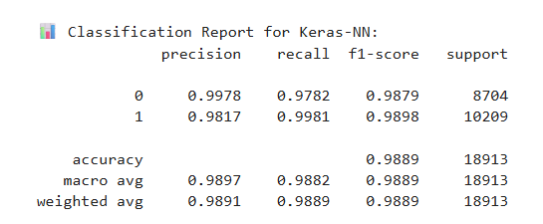

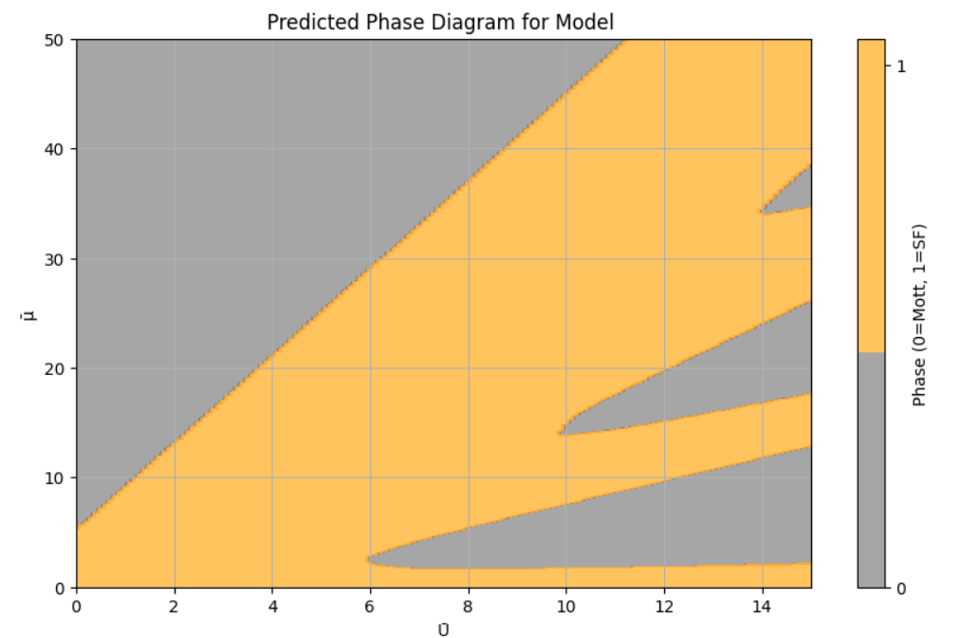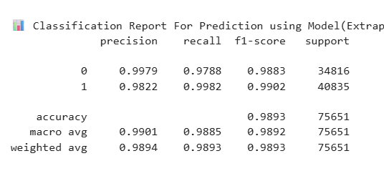

Results on Dataset-2

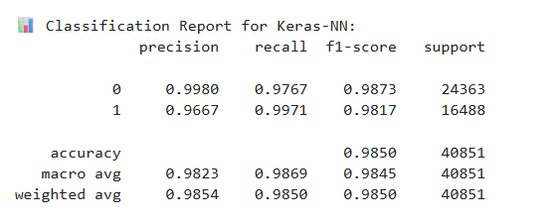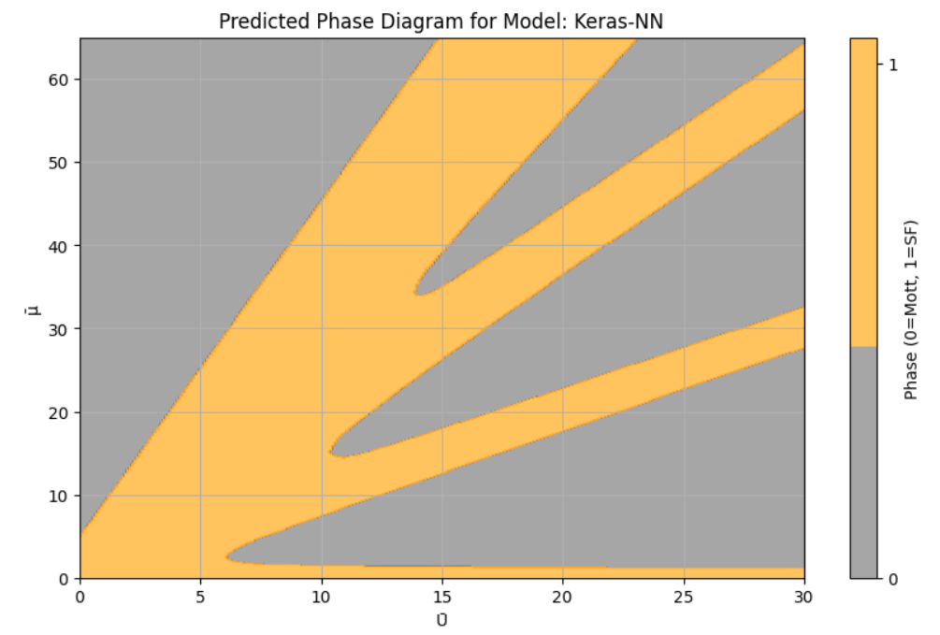

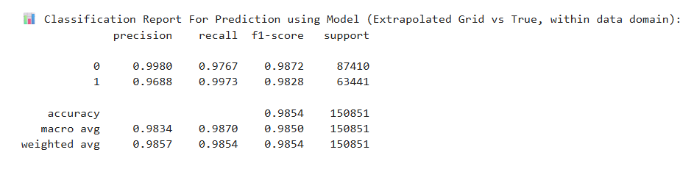

Results on 30k

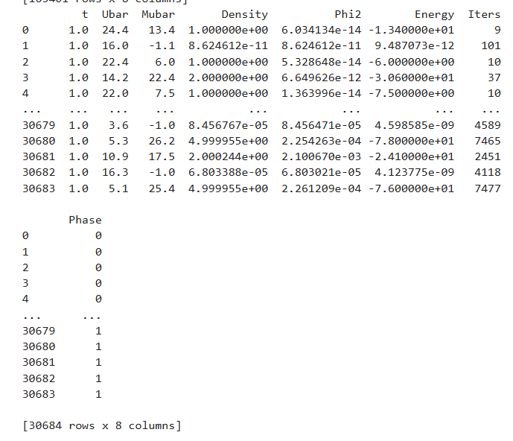

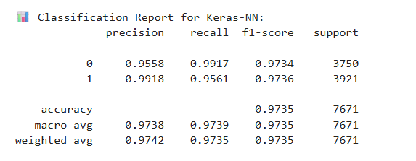

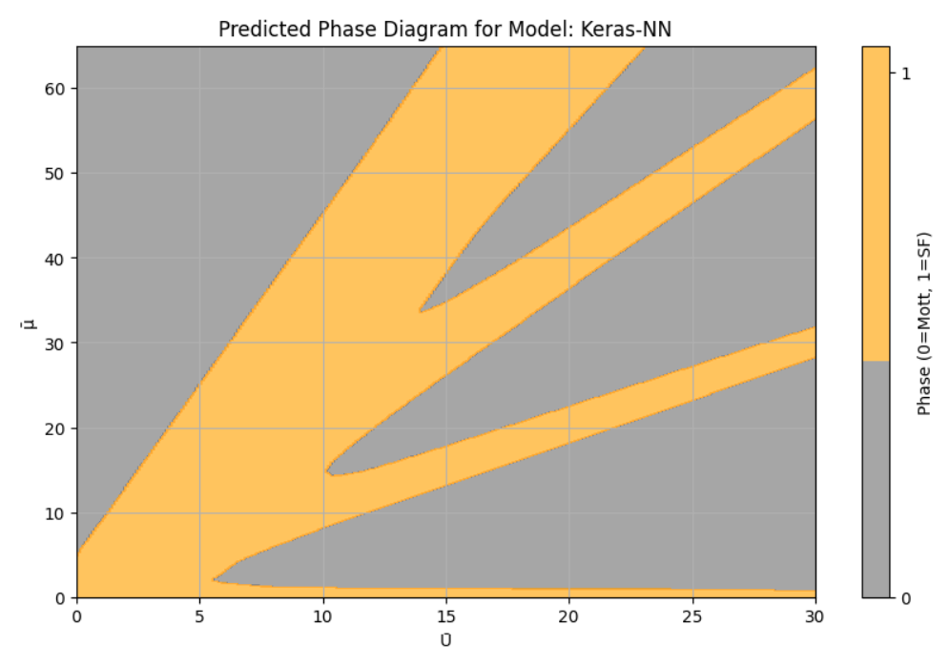

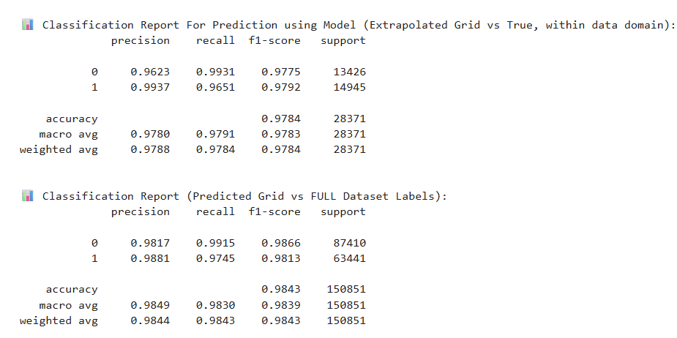
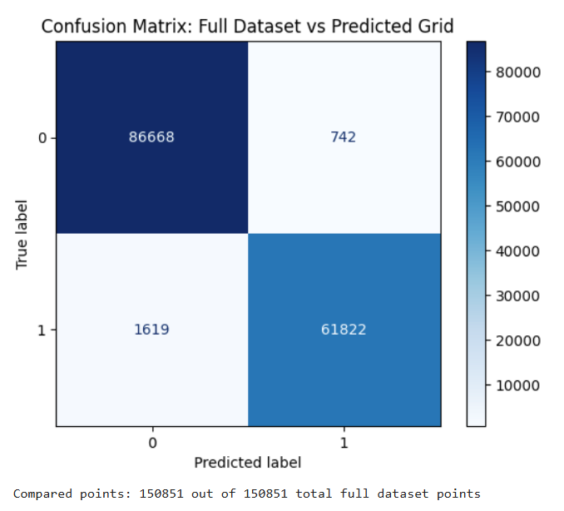

Results on 10k ( D2)
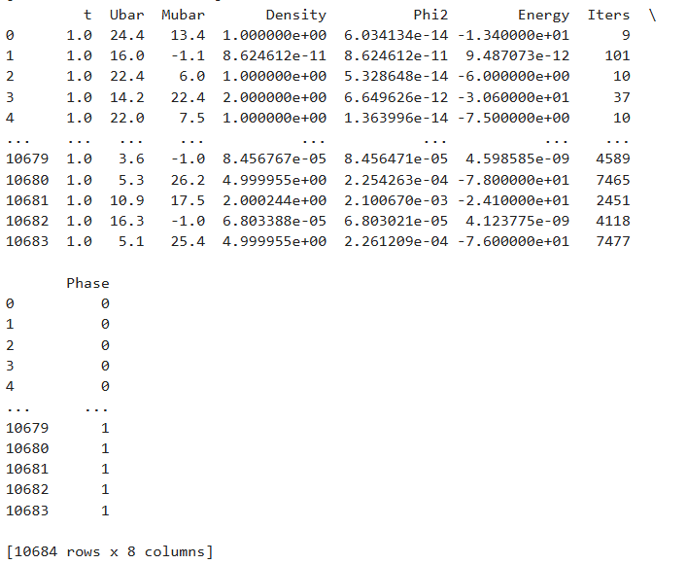

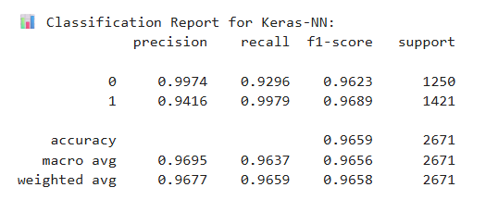

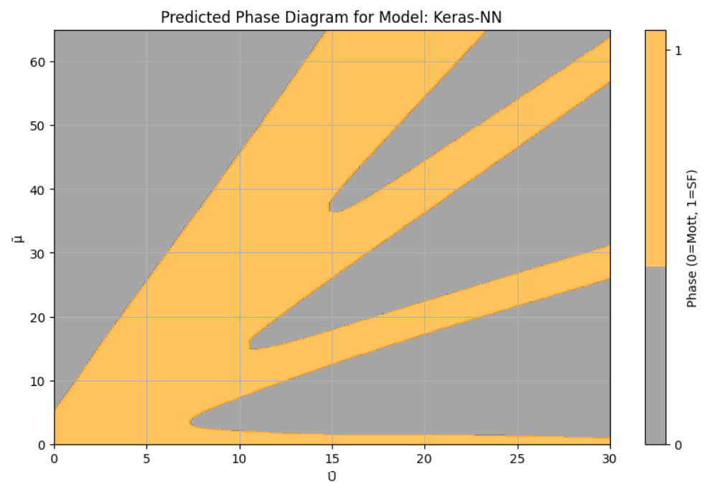

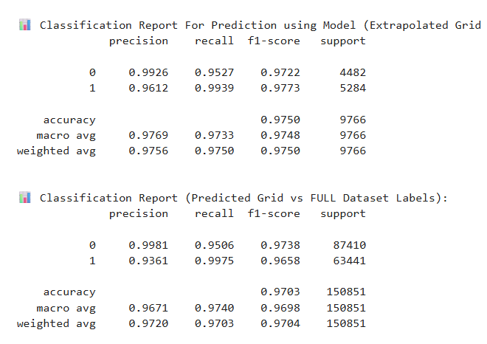
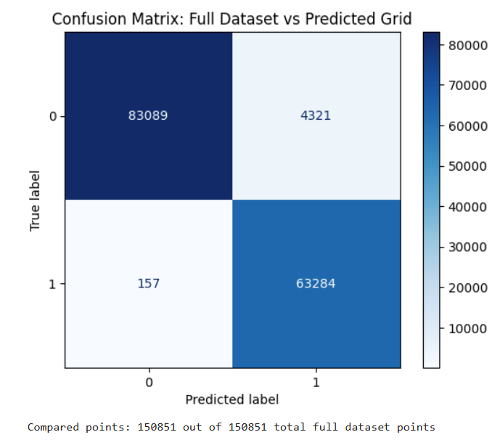

Results on 6k

